**ASSIGNMENT 1 UMAPRIYA SELVAM Roll no.:CITC1904119**

1. **Split this string**

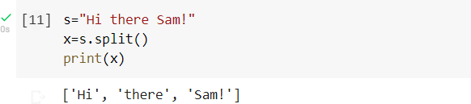

1. **Use .format() to print the following string.Output should be: The diameter of Earth is 12742 kilometers.**

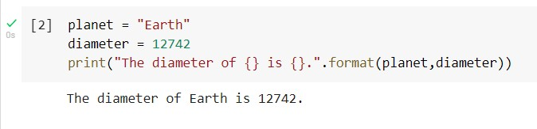

1. 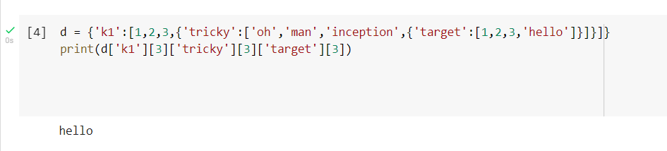**In this nest dictionary grab the word "hello".**

4.1 Create an array of 10 zeros? 4.2 Create an array of 10 fives?

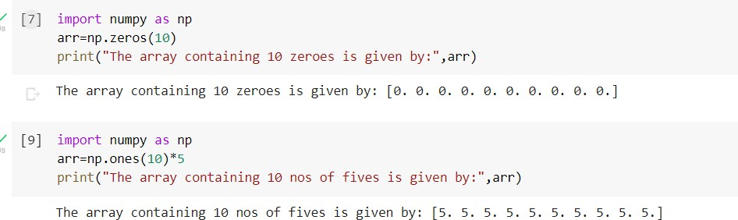

1. **Create an array of all the even integers from 20 to 35**

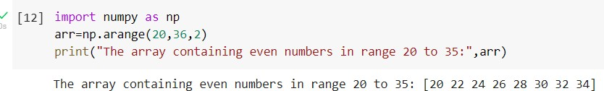

1. **Create a 3x3 matrix with values ranging from 0 to 8**

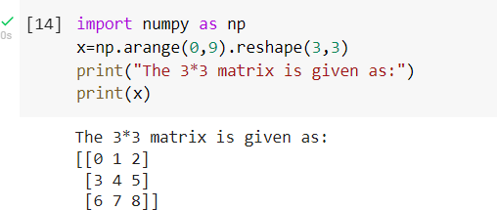

1. **Concatenate a and b**

a = np.array([1, 2, 3]), b = np.array([4, 5, 6])

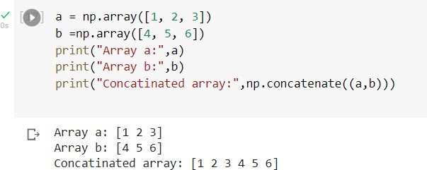

1. **Create a dataframe with 3 rows and 2 columns**

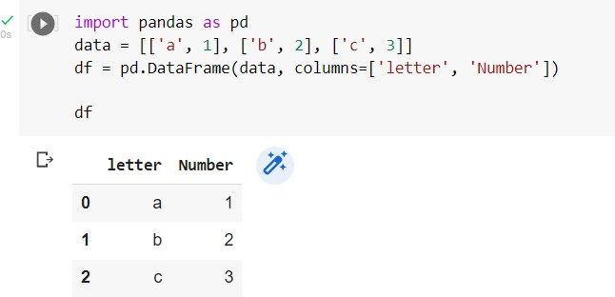

1. **Generate the series of dates from 1st Jan, 2023 to 10th Feb, 2023**

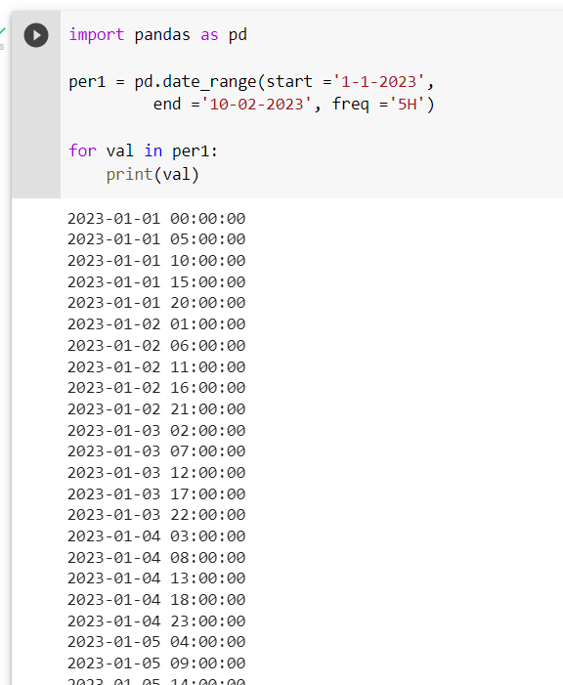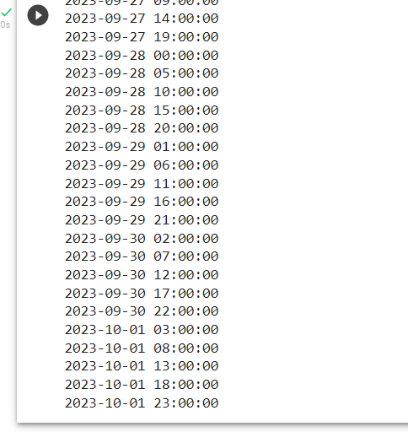

1. **Create 2D list to DataFrame**

lists = [[1, 'aaa', 22],

[2, 'bbb', 25],

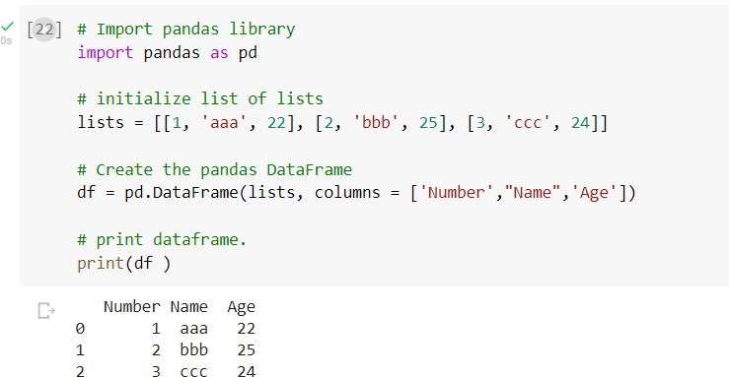 [3, 'ccc', 24]]